EWV 12000
Category: 5500-12500 lbs, Electric Winch, EWV Series, Tow Truck Winch

SPECIFICATIONS
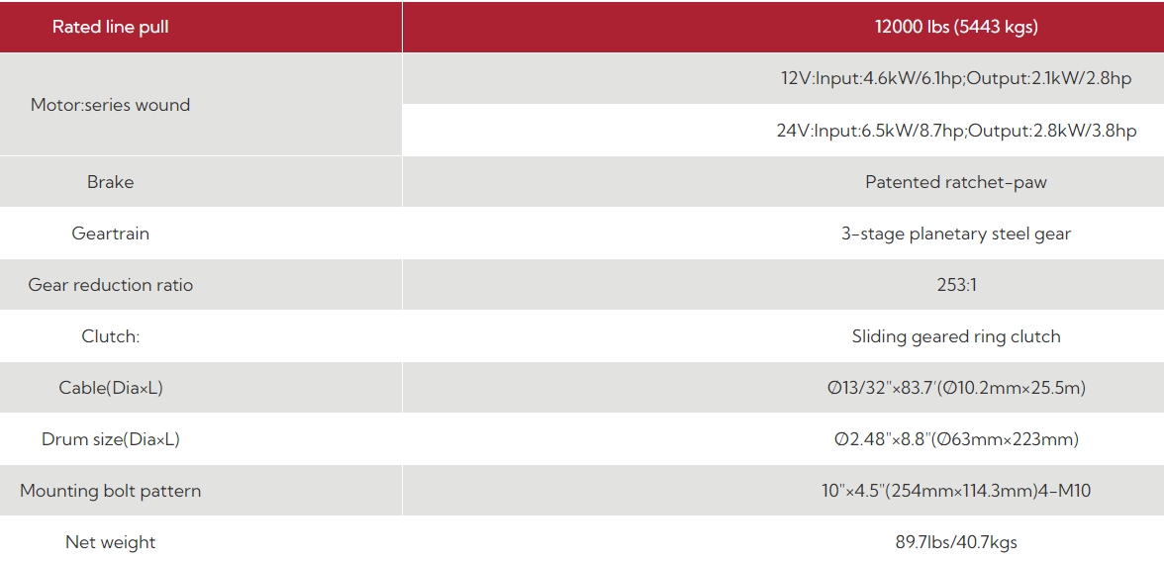

DIMENSIONS
